Document Status
Title: | Azure Data Factory Git Integration
Author: | Balaji Dhanavanthan
Owner: | Systech Solutions
Version: | V 2.0
Date Issued: | 06-09-2025

Git Setup for Azure Data Factory
Git Setup for Azure Data factory

Step 1: Create or Choose a Git Repository
Azure Data Factory supports integration with Git services like Azure DevOps and GitHub. Ensure that you have an existing Git repository or create a new one.
• Azure DevOps Repository: If you’re using Azure DevOps, you’ll need an organization, project, and a Git repository within it.
• GitHub Repository: You can also link a GitHub repository by having a GitHub account and an active repository.

Step 2: Set Up Git in Azure Data Factory
Follow these steps to link your Git repository to Azure Data Factory.

2.1: Open Azure Data Factory Studio
• Navigate to Azure Data Factory: Go to the Azure Portal and find your Azure Data
Factory instance. Click on the Author & Monitor tile to open ADF Studio.
• Go to the Git Configuration Page: In the ADF Studio, click on the Manage tab (the
wrench icon) on the left side of the page.
• Configure Git: Under the Git configuration section, click New or Edit (if you are
changing an existing configuration).
Git Setup for Azure Data factory
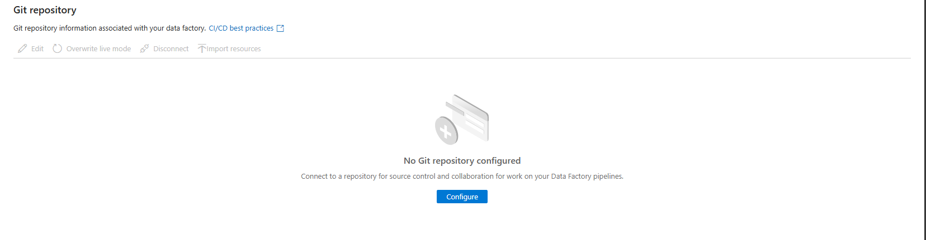

2.2: Configure Git Repository
Depending on whether you are using Azure DevOps or GitHub, the configuration steps vary
slightly.
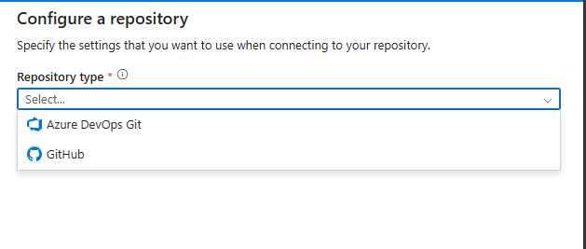

For Azure DevOps:
Select Azure DevOps as the Git Provider.
• Organization Name: Enter the name of your Azure DevOps organization.
• Project Name: Select or enter the name of the Azure DevOps project containing the
repository you want to link.
• Repository Name: Select the Git repository within the project.
• Collaboration Branch: Typically, main or master is used for the main collaboration
branch. You can also specify a different branch if necessary.
• Root Folder: Enter the root folder (e.g., / if you want the entire repository or any
specific folder within the repo).

• Authentication Type: You can authenticate using Personal Access Token (PAT) or
OAuth. For the easiest configuration, use OAuth. If using PAT, enter the Personal
Access Token created in Azure DevOps. If using OAuth, Azure will authenticate you
using your logged-in account.
• Save: Click Save to finish the configuration.

For GitHub:
Select GitHub as the Git Provider.
• Repository Name: Enter the GitHub repository name (e.g.,
https://github.com/username/repo).
• Collaboration Branch: Select the default branch (usually main or master).
• Authentication Type: OAuth or Personal Access Token (PAT) can be used.
• If using OAuth, sign in with your GitHub credentials and allow Azure Data Factory to
access your repository.
• If using PAT, you can manually enter the token you generated from GitHub.
• Save: Click Save to finish the configuration.
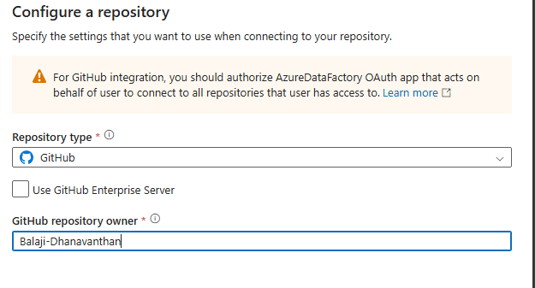

Step 3: Deploy Code to Git
Once the Git repository is configured, you can deploy your ADF assets (like pipelines, datasets, linked services, and triggers) into the repository.
• Create and Edit Resources: You can now begin creating and editing ADF resources.
Any changes you make will be tracked in the Git repository.
• Commit Changes: Once you’ve made changes (e.g., adding a new pipeline or
updating a dataset), you’ll need to commit those changes: Click on Publish All in the
ADF Studio to commit changes to the Git repository. You will be prompted to enter a
commit message and then publish the changes.
• Push Changes: After committing, the changes are pushed to your Git repository.

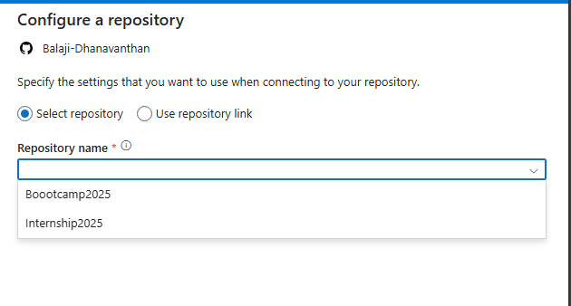

Step 4: Branching Strategy
Azure Data Factory also supports branching in your Git repository, which allows for version control
during development and deployment.
• Create Feature Branches: Use feature branches to isolate your changes for different
environments or features.
• Merge and Deploy: When you’re ready to deploy to a different environment, merge the feature branch with the main branch and then publish those changes from ADF.

